About Page Design

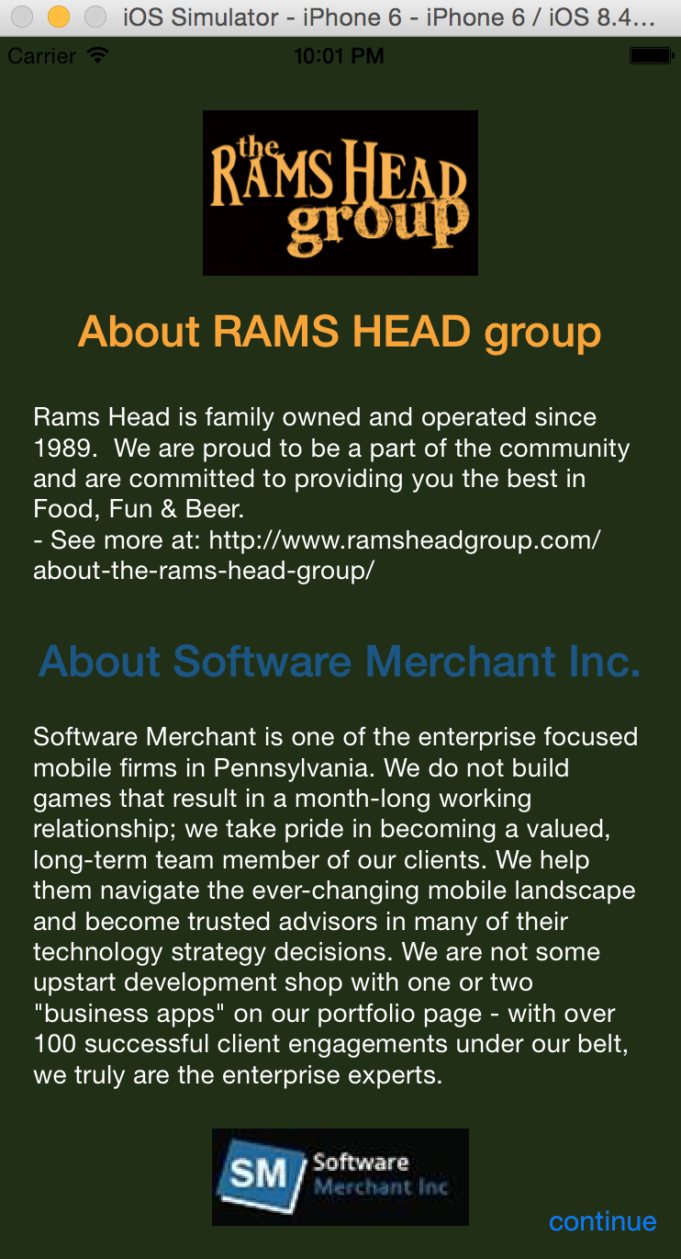

**Elements:**

Status bar: hidden

Background: dark green(according to the website of RAMS HEAD group)

“Rams Head group” logo: cut from the website

About title: 1 for Rams Head group(in orange), 1 for Software Merchant Inc.(in blue)

About content:

font in white, size 14

Part 2. Software Merchant Inc. introduction.

Part 1.

Rams Head group introduction

Software Merchant Logo

“continue” button: segue to the login or register page